Password Cracking Challenge 1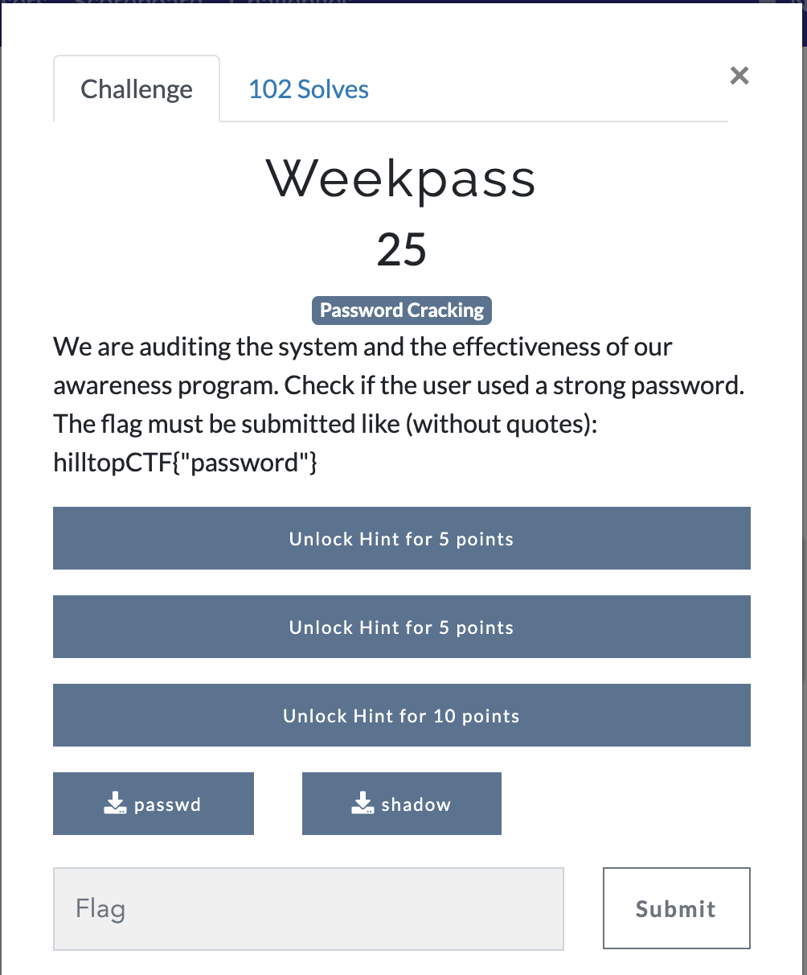
Anwser: We are given a passwd and shadow file, this are common on linux systems. We are going to use johntheripper to crack this.
First we need to combine the two files. Command: unshadow passwd shadow > PassCrack
Second, let john crack it using the rockyou wordlist. Command: john PassCrack --wordlist=rockyou.txt
Finally we get our password. hilltopCTF{welcome01}
